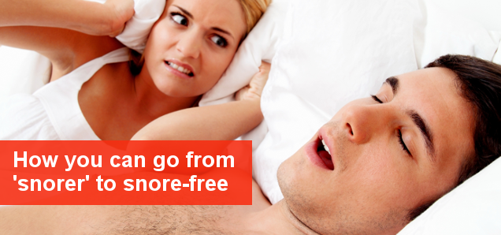
Think you’ve tried everything for snoring? Think again
Snoring is a gruelling problem which takes its toll on your health and the tolerance of your family – but you do have a choice
If you consider yourself ‘a snorer’ it is likely you’ve tried almost every treatment under the sun. Going through the motions of trying a number of treatments is something that most snorers go through and it can be disheartening. If you’ve tried nasal strips, sleep appliances, CPAP therapy and more without success it’s important to know you have not exhausted all of your options. There is a new advanced treatment being pioneered in Australia by Hunter Laser Centre in Kotara, NSW.
Having tried all of these sleep appliances and anti-snoring treatments it’s likely that you’ve asked yourself – ‘is treating my snoring really worth the time and money?’
Stopping snoring is not always about pleasing other people like your partner or family. Snoring can also lead to significant health problems, which is why you should care about your snoring even if it doesn’t affect anyone else.
Can snoring affect your health?
Yes.
Snoring can result in a number of complications especially if left untreated for a long period of time. Health problems snoring can contribute to include:
- Chronic fatigue
- High blood pressure which can lead to higher risk of heart attack and stroke
- Low oxygen levels which can lead to the narrowing of the arteries

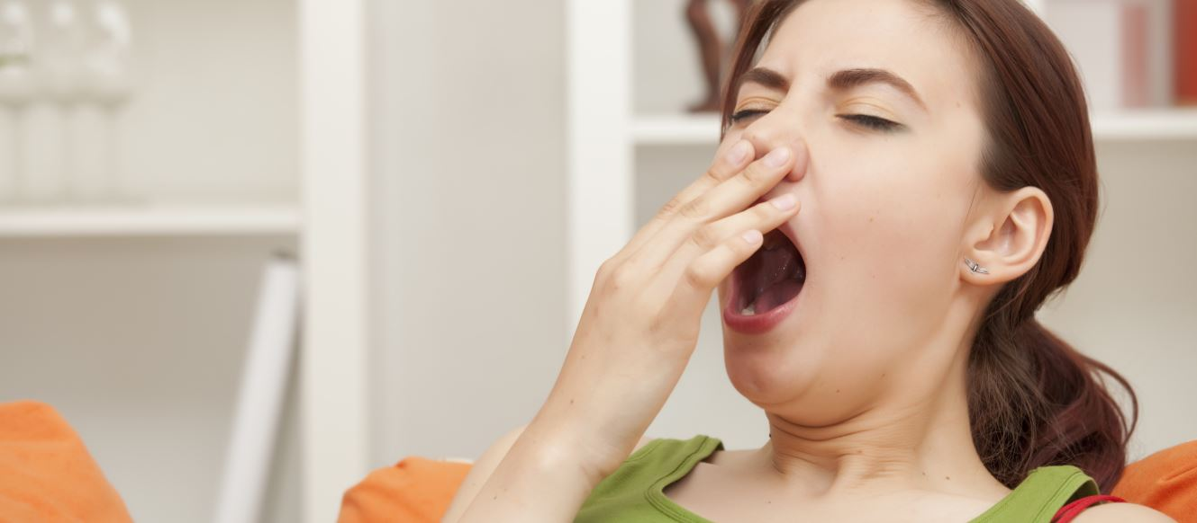
I’ve tried everything – what do I do?
There is a revolutionary laser called NightLase which uses a similar laser to those used in cosmetic clinics to rejuvenate the skin. The NightLase procedure will strengthen the tissue and fibres beneath the skin in the throat – which can obstruct the airway during sleep.
Many patients who have tried other anti-snoring treatments achieve success with this laser snoring procedure. The treatment is virtually pain free and will achieve full results in approximately 45 days as the tissue begins to change. Over this 45 day duration you will be required to receive three laser procedures. Your appointments will take place on the first day, the fifteenth day and the forty-fifth day.
Can anti-snoring laser treatment be used for OSA/Obstructive sleep apnoea?
Yes in some cases patients have achieved success with the NightLase procedure for OSA, although treatment for this can differ slightly when compared to other causes of snoring. If you have been diagnosed with OSA and wish to find out if NightLase will work for you, please book an initial assessment with Hunter Laser Centre in Kotara.
Your guide to sleeping better after treatment
Once your forty-five day treatment period is complete you should notice a significant difference in your quality of sleep. If you want to make the most of your new deeper sleep then please take a look at these tips for a better night’s sleep.
- Ensure your room is as close to pitch black as possible
- Ensure your room is cooler rather than hotter
- Try to wake up at the same time every day
- If you have trouble sleeping at night avoid napping
With these tips, and our anti-snoring treatment we’re sure you’ll be able to achieve a perfect night’s sleep.
To find out more about our laser snoring treatment please call us on 02 4920 6565 or enquire below.
<Enquire today>

