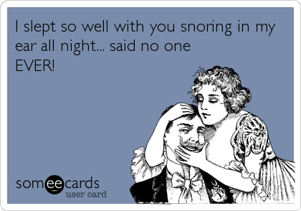
Partners of snorers report they have just 3-5 hours of sleep per night.
Think about your partner when you’re considering treatment for snoring.
Find out more: http://www.hunterlaser.com.au/sleep-apnoea/

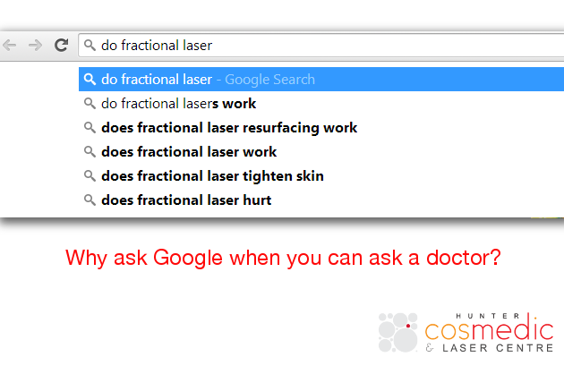
Comment your questions below!
Discover the true age of your skin… http://www.huntercosmedic.com.au/skin-analysis/

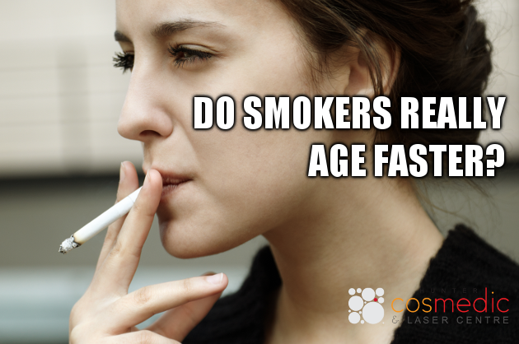
Everyone has heard that smokers age faster… but is it a myth or fact?
FACT your blood vessels thin and spasm when you smoke. This reduces circulation and decreases how oxygenated your blood is. This is vital in maintaining skin appearance.
No amount of skin cream will help this… dermatologists and cosmetic doctors alike both recommend laser treatments. Find out more: http://www.huntercosmedic.com.au/laser-treatments/

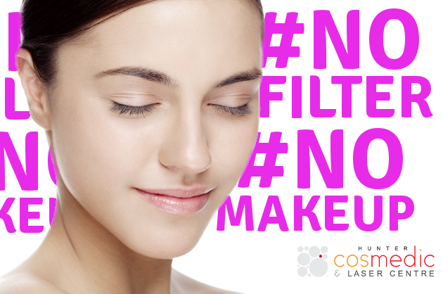
There’s been a lot of #nomakeup trends going around… While this may not be a ‘trend’ persay there are ways you can improve your appearance without makeup!
Our Total Facial Rejuvenation treatment could be just what you need: http://www.huntercosmedic.com.au/total-facial-rejuvenation/

<screenshot from link>
Take a look at this no makeup gallery featuring models from recent runways! Vogue is calling this ‘Raw beauty’ what do you think about it?
http://www.vogue.co.uk/beauty/2014/03/26/raw-beauty-spring-summer-2014-no-makeup-trend/gallery/1051445

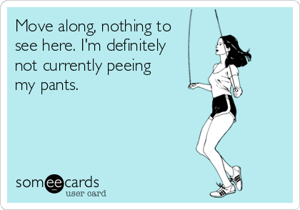
Exercising with LBL can be difficult – and if we’re being honest downright troublesome and even embarrassing.
It’s important to know that you’re not alone – lots of women suffer from this. There are also effective treatment options available. Find out about Incontilase today: http://www.hunterlaser.com.au/urinary-incontinence

Do you miss nice looking nails? Fungal nail infections can be treated with laser therapy. http://www.hunterlaser.com.au/onychomycosis

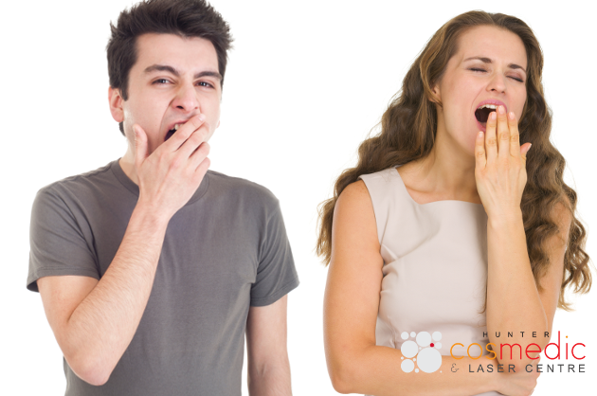
Waking up tired is not normal – neither is snoring.
Snoring is a symptom that needs treatment, just like any other problem. We have one of the most innovative treatments available – laser treatment for snoring.
Find out more here: http://www.hunterlaser.com.au/sleep-apnoea/

Sick of kegels? We have news for you! http://www.hunterlaser.com.au/media-centre/vaginal-laser-healthy-choice/

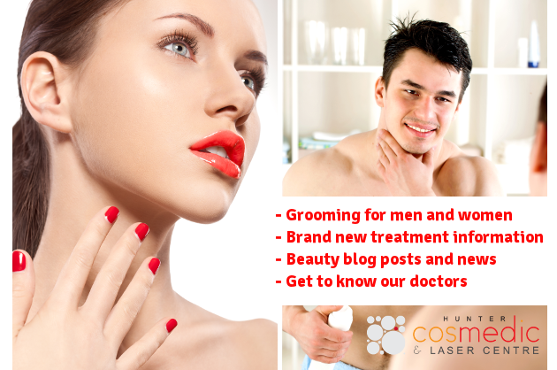
Stay up to date on our blog for exclusive information http://www.huntercosmedic.com.au/patient-centre/blog/

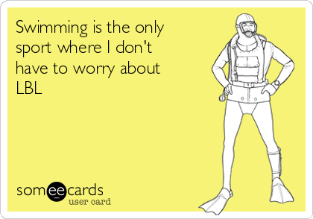
LBL shouldn’t run your life.
You should be able to enjoy whatever sport you want. Take control of your bladder today: http://www.hunterlaser.com.au/urinary-incontinence

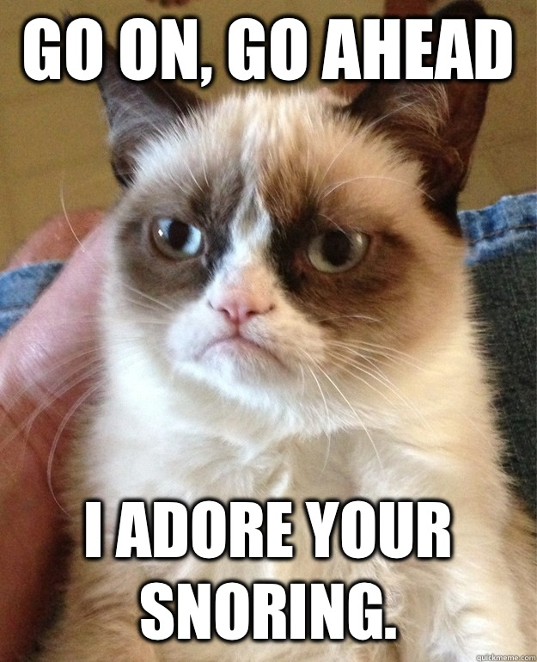
Over one third of couples report disharmony within the relationship due to snoring.
Should partners have to get treatment for snoring? Let us know what you think in the comments


Kate Hudson is 35 years old and looking great! Great, clear skin

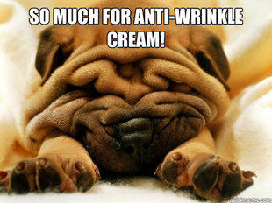
Are you wasting money on skin care products? http://www.huntercosmedic.com.au/Are-you-Wasting-Money-on-Skin-Care-Products

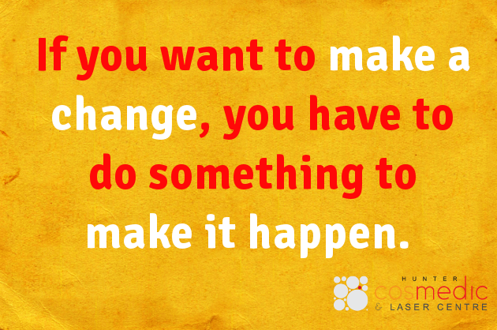
If you want to improve your appearance you have to take action. Take a look at our cosmetic treatments for ways you can improve your appearance. http://huntercosmedic.com.au/

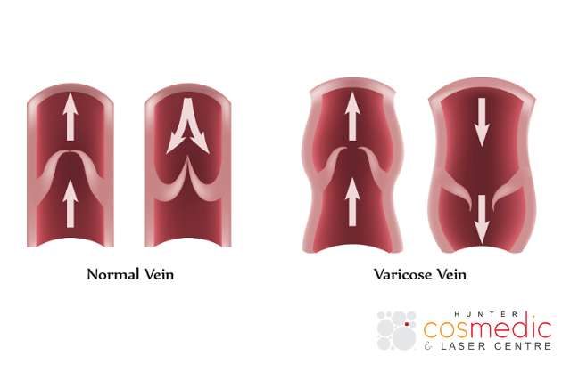
Varicose veins are when the valve no longer operates properly, which results in blood pooling in the vein. This gives the veins their raised appearance and also puts extra strain on that vein.
There is no harm in removing varicose veins as they do not operate correctly and therefore are not properly assisting circulation.
Find out more about varicose vein removal: http://www.huntercosmedic.com.au/veins-and-capillaries/

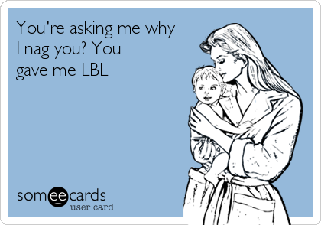
Has anyone ever used this excuse?

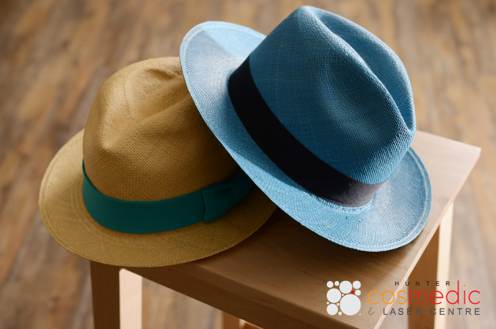
For all our cosmetic laser patients – don’t forget to protect your skin from the harsh winter sun! It’s a good thing hats are in

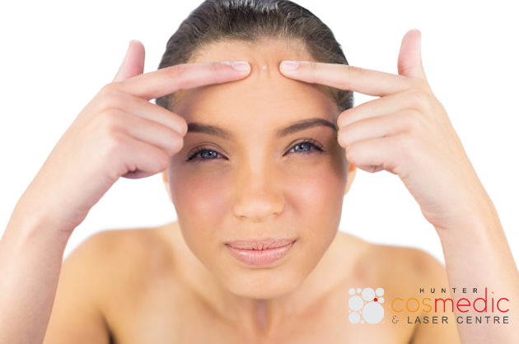
STOP BEFORE YOU POP
You may think that clearing out pimples by popping them helps but it’s actually one of the biggest acne mistakes!
It prolongs healing time and may even deepen the infection, which can lead to swelling and pain. Not to mention scarring which can usually only be treated with laser therapy (http://www.huntercosmedic.com.au/acne-treatment/)
Stay tuned for more acne mistakes!

Over using acne medication and anti-acne products can worsen the condition of your skin.
If you want to treat acne at the source look into our acne laser treatment: http://www.huntercosmedic.com.au/acne-treatment/


Acne is not just for adolescents, adults can suffer from acne as well.
If you are an adult with acne and you feel like it’s affecting your social and professional life you could benefit from our laser treatment. Find out more: http://www.huntercosmedic.com.au/acne-treatment/

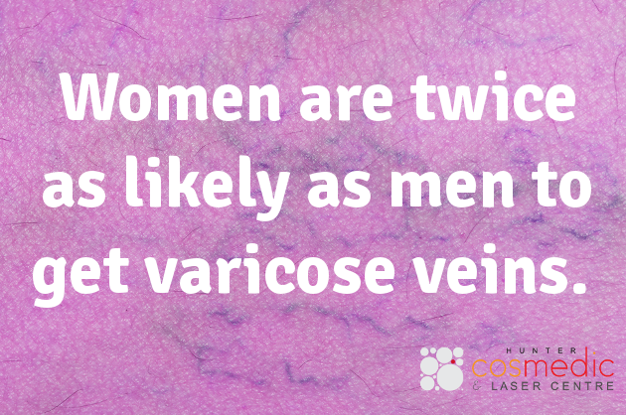
Unfortunately this is the case, but luckily there is treatment available in the form of laser therapy. http://www.huntercosmedic.com.au/veins-and-capillaries/

<screenshot from article>
Think you’ve tried everything for snoring? THINK AGAIN

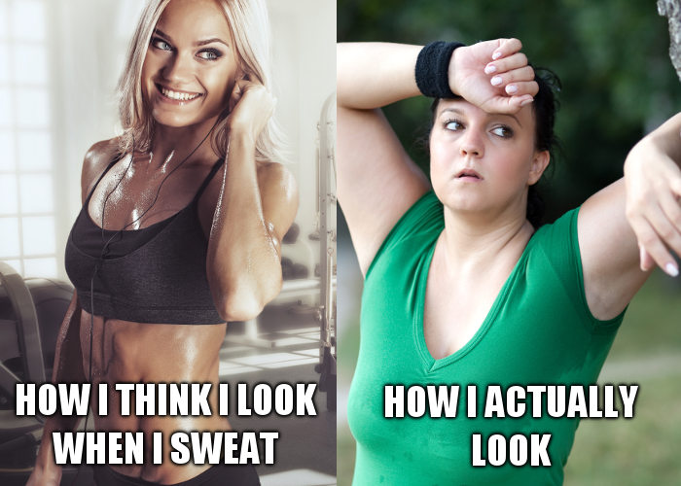
If you have trouble sweating please take a look at our sweating treatment: http://www.huntercosmedic.com.au/severe-sweating/

Have a question about our laser treatments, our pricing or anything else? Feel free to private message us or comment below.

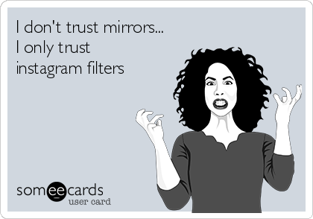
Love your mirror more: http://www.huntercosmedic.com.au/total-facial-rejuvenation/
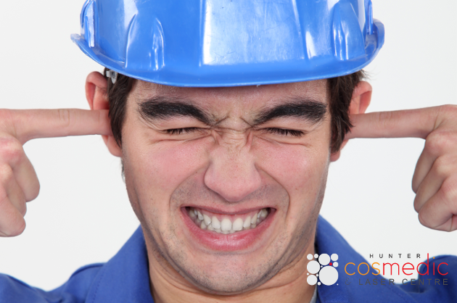
Did you know snoring sounds range from 50 to 100 decibels – this is the same as a pneumatic drill.
If you don’t think you could sleep with a drill in your room then you couldn’t sleep with a snorer either! Treating snoring is important for your health, not to mention beneficial to your relationships.
Find out more: http://www.hunterlaser.com.au/sleep-apnoea/

Lasers tighten more than just the skin on your face: http://www.hunterlaser.com.au/vaginal-tightening/

<screenshot>
http://www.hunterlaser.com.au/patient-centre/media-centre/
Stay up to date with our medical laser procedures!

